**Assignment -2**

**Python program**

|  |  |
| --- | --- |
| Assignment Date | 24 September 2022 |
| Student name  Student Roll No  Maximum Marks | Chandhni C  710019106009  2 Marks |

**1.Build a python code**:

Assume u get a temperature and humidity values (generated with random function to a variable) and write a condition to continuously detect alarm in case of high temperature.

**Code Solution:**

import random

def temperature():

value=random.randint(25,100)

return value

t=temperature()

t=int(input(“Enter the temperature value:”))

def humidity():

range=random.randint(40,100)

return range

h=humidity()

h=int(input(“Enter the humidity value:”))

#TEMPERATURE

if t>30:

print("High temperature is detected")

print(“Buzzer on, alarm sound is high”)

elif t==30:

print("Temperature reached maximum threshold of 30 degrees Celsius")

else:

print("Temperature is good")

#HUMIDITY

if h>65 :

print("High humidity detected")

print(“Buzzer on, alarm sound is high”)

elif h==65:

print("Humidity reached maximum threshold of 65 percent")

else:

print("Humidity is good")

**PROGRAM**

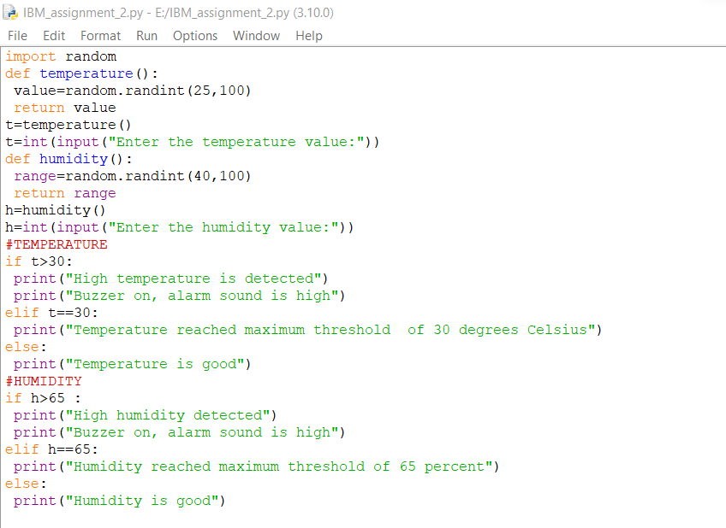

**OUTPUT**

